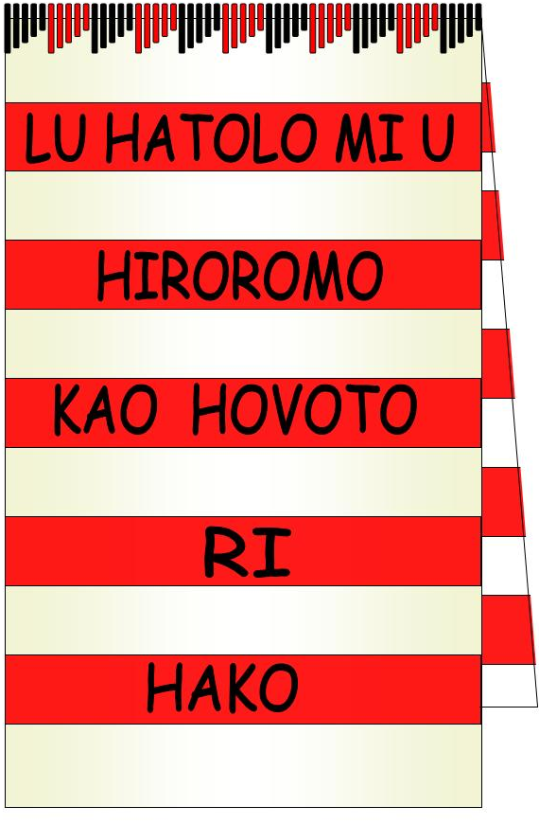
HWC TEAMS: QUARTERLY PROGRAM & REGISTER Environment Education & Advocacy Q1 & Q2 2015

HWC Objective /  Strategy (SAP 2015-2017) | PROGRAM TEAM COORDINATORS | TEAM MEMBERSHIP
Q1 ’15 Resource Centre Development Phase | Team A – Anna Sapur | Bridgitte Tologina, Sakoe Gano, Jacob Alphan, Kelsi Alphan, Herman Tologina, Augustine Tologina, Priscilla Alex, Rylyne Billy, Natholi Kisu,
Q2 ’15 RC Establishment & HWC AGM / Elections
Q3 ’15 HWC Training & Equipping Phase | Team B – Judy Lega | Cindy Kehali, Gregory Tagu, Roselyn Limen, Dominic Karakato, Richard Nawan, Gloria Lambert, Gala Kelvin, Hagete Peter, Asike Tasa
Q4 ’15 Operations Phase
& 16 Days of Activism

1. VISION (Mehe) Hako: Lu hatolo mi u hiromomo kao hovoto ri Hako Collective

English: In the spirit of love and true sisterhood, we the women of Hako Collective are called to build a safe, secure and just environment within our families and communities AND Create an integrated sustainable development that will establish a better future for our children and children’s children.
- MISSION (Tukui) Hako: Aga u Kao ri Hako ke hihitaguhu, hihatuts, bate hatapa haniga e naga a han I tagaga

English: In response to the current situation in our community, we the women of Hako are committed to work together, help each other and teach and train our people to build a safe, secure, just and peaceful society creating an environment conducive to sustainable, integrated development for the common good of our children and their children.
- OBJECTIVES
a) To facilitate and co-ordinate Trainings/Workshops and Forums for the women’s groups in the Hako Area and maintain the spirit of friendship, partnership with women
and the community in peace building, reconciliation and weapons disposal in Hako; and

b) To educate and train women and youth, developing their human capacity in empowering them with life skills, leadership and decision making, community advocacy supported by partnership Women’s Federation, Government, CSO and Non Government Agencies to access the necessary educational resources; and
- To ensure and endorse representation of women in politics and in decision making bodies in government, non government organisations and the private sector; and
- To represent women and their families concerns and to advocate for their economic empowerment and development through projects that aim to reduce poverty in families in Hako; and
- To represent the women of Hako and network with, national, pacific and international women’s organisations and women’s movements’ and
- To protect Hako’s environment, heritage and culture and to promote the proper management of natural resources as mothers of the land in a matrilineal society with Environmental Education and Advocacy (EEA) and Pacific Black Box (PBB) teams; and
- To source funding and management capacity for women’s infrastructure and community development and programs in Hako to ensure effective delivery with accountability for sustainable development with Community Development (CDI) teams and PBB media; and
- To strengthen and encourage the marginalized persons or groups of persons in society by providing literacy, life enhancing skills, formal education opportunities and advocating for health services and family well being through Women’s Integrated Education and Advocacy (WIEA) and PBB teams in Hako.

HWC EXECUTIVE assessment and endorsement of team program | Q1 ‘15 | Q2 ‘15 | Q3 ‘15 | Q4 ‘15
Item A: Program is conducted on line with HWC Objectives & Strategy?
Item B: Program is in Scope with the HWC Objectives and Strategies
Item C: Program is in Budget with HWC capabilities?
Item D: Any Risks or concerns with the program?

Comments:
- EEA needs to recruit extra voluntary assistance with ground clearing, grass cutting in the weeks before Easter
- Soil and mulch is required for the backyard farm project area before setting up the garden beds

- Need to draw up a plan of the garden and grounds layout with formal arrangement of planted rows in the frontage

-Need to plan for collection of flowers & shrubs for the planting (donations)

ENVIRONMENTAL EDUCATION & ADVOCACY (EEA) HWC QUARTERS 1 & 2 2015
PROGRAM Report prepared by: | Anna Sapur, Judy Lega, Bridgitte Tologina, Marilyn Havini
Date Report submitted to Exec: | Monday 9th March 2015
Date Presented to HWC Membership: | Tuesday 10th March 2015

HWC TEAM: EEA |  |  | ENVIRONMENTAL EDUCATION & ADVOCACY
Program  Week & Day No. | DATE |  | HWC  Objective | Program |  |  | Activities |  |  | Who is  Responsible  (Team Leader) |  |  | Cost of Activity | Register date &  sign when completed
1 | 27/2/15 |  | b), f) | Recruitment for teams & Program Planning |  |  | Organize programs for every Friday and draft Program & Activities for February- June 2015 |  |  | Anna Sapur &  Judy Lega |  |  | Nil
- | 6/3/15 |  | a), e) | International Women’s World Day of Prayer |  |  | All participate in Hako Women’s Fellowships Prayer Day at Tegese UC |  |  | Ainsley Hansiana |  |  | Nil- indiv.  food & offering
2 | 13/3/15 |  | b), d), f) | Planning RC & HWC Grounds  & RICE MILLING - Fridays |  |  | -Design layout of HWC grounds with border gardens and front formal planting  - Set up Rice Mill for day of milling production for community, grass cutting |  |  | Anna Sapur, Judy Lega, Rice Mill: Elizabeth Lambert with Pastor Andy Kolots, R Nawan |  |  | Grease & Fuel for Mill,  K10 grass cutting
3 | 20/3/15 |  | b), d), f) | GROUNDWORKS: Resource Centre Garden & Food Security Beds, Planting  /Community Rice Milling |  |  | Stake out the planting lines, Soil digging & preparation, Planting of side hedges. Make garden stakes, borrow string, garden tools, collect flowers / shrub cuttings / Set up Rice Mill for Community |  |  | EEA Teams & Leaders |  |  | Grease & Fuel for Mill,  Equipment loans & donations
4 | 27/3/15 |  | b), d), f) | GROUNDWORKS: Resource Centre Garden & Food Security / Rice Milling |  |  | Planting of formal frontage in 3 rows of graduating heights & erect bamboo protection fence / Set up Rice Mill for Community |  |  | EEA Teams & Leaders |  |  | Labour costs?
- |  |  | NIL | EASTER |  |  | GOOD FRIDAY
5 | 10/4/15 |  | b), d), f) | GROUNDWORKS: Resource Centre Garden Maintenance  & Community Rice Milling |  |  | Watering, weeding, replanting, / Set up Rice Mill for Community |  |  | EEA Teams & Leaders |  |  | Grease & Fuel for Mill,  Equipment loans & donations
6 | 16/4/15  17/4/15 |  | a), b), d), f) | OFFICIAL OPENING of Resource Centre: Preparation, Monitoring & Clearing up after event  & Community Rice Milling |  |  | Grounds cleaning, preparation for opening with floral decorations, formal seating, grounds ‘banis’ protectors of layout for crowd control, maintenance/ Set up Rice Mill for Community |  |  | EEA Teams & Leaders |  |  | Tools & Equipment loans & donations
7 | 24/7/15 |  | b), d), f) | Plan for International Environment Day & Month of MAY Awareness Program  / Community Rice Milling |  |  | -Sort all Environment Resources & list potential choices for Hako Schools  - Write letters of invitation to all Kindy’s Elementary, Primary & High School/s in Hako,  -Copy DVDs & Resources needed for booked awareness programs |  |  | EEA Teams & Leaders  & Hako Media Unit |  |  | Copies of Digital Resources, Stationery, Printing, Flex Cards
8 | 1/5/15 |  | b), d), f) | Prepare Environmental Educational Programs  / Community Rice Milling |  |  | Plan PROGRAMS with resources, Digital media & group activities suitable for each age group in School Assemblies & class bookings |  |  | EEA Teams & Leaders  & Hako Media Unit |  |  | Copies of Digital Resources, Stationery, Printing, Flex Cards
9 | 4-8th /5/15 |  | a), b), d), f) | ENVIRONMENT WEEK  / Community Rice Milling |  |  | Full week of bookings for HMU and EEA to conduct Environmental Awareness Programs in schools throughout Hako COE |  |  | EEA Teams & Leaders  & Hako Media Unit |  |  | Stationery, Printing, Flex Cards,  Fuel for Milling,
10 | 8/5/15 |  | a), b), d), f) | Month of MAY Educational ENVIRONMENTAL Awareness programs continue with bookings  / Community Rice Milling |  |  | HMU and EEA to conduct Environmental Awareness Programs in schools throughout Hako COE |  |  | EEA Teams & Leaders  & Hako Media Unit |  |  | Stationery, Printing, Flex Cards,  Fuel for Milling,
11 | 15/5/15 |  | a), b), d), f) | Month of MAY Educational ENVIRONMENTAL Awareness programs continue with bookings  / Community Rice Milling |  |  | HMU and EEA to conduct Environmental Awareness Programs in schools throughout Hako COE |  |  | EEA Teams & Leaders  & Hako Media Unit |  |  | Stationery, Printing, Flex Cards,  Fuel for Milling,
12 | 29/5/15 |  | a), b), d), f) | Month of MAY Educational ENVIRONMENTAL Awareness programs continue with bookings |  |  | GENERAL MEETING OF EEA MEMBERS – monitoring of the EE activities & HMU and EEA to conduct Environmental Awareness Programs in schools throughout Hako COE |  |  | EEA Teams & Leaders  & Hako Media Unit |  |  | Stationery, Printing, Flex Cards,  Fuel for Milling,
13 | 5/6/15 |  | b), d), f) | Monitor & evaluate the EEA program & Awareness for AGM Report  / Community Rice Milling |  |  | Complete compilation of all reports from all EEA Q1&2 programs & awareness bookings, evaluate and compose EEA formal report |  |  | EEA Teams & Leaders |  |  | Stationery, Printing,  Fuel for Milling,
14 | 11/6/15  12/6/15 |  | a), b), c), d), f) | HWC AGM/ Elections & 9th Anniversary Celebrations |  |  | Presentation of EEA formal report to HWC AGM |  |  | EEA Teams & Leaders |  |  | Stationery, Printing,
15 | 19/6/15 |  | b), c), d), f) | Reorganize & Planning with the elected HWC Executive  / Community Rice Milling |  |  | Re-strategize according to priorities set by incoming Executive according to the HWC 3 year Strategic Action Plan |  |  | EEA Teams & Leaders |  |  | Stationery, Printing,  Fuel for Milling,
16 | 26/6/15 |  | b), d), g) | EEA complete Q3 and Q4 Program / Community Rice Milling |  |  | Prepare funding proposals, complete HWC Program Template for Q3 & Q4 |  |  | EEA Teams & Leaders |  |  | Fuel for Milling,
Quantity |  | Funded Item |  |  | Units | Description |  | Funding source | Receipt No |  | Unit Price | Total
15 |  | Fuel for Rice Milling, |  |  | Fridays | Est. 4 litres each Friday |  | Charge Customers K2 per Kilo of Rice milled |  |  | K5 per litre | K20 x 15= K350
x 5 |  | Grease for Rice Mill |  |  | Fridays
x 2 Team Leaders |  | Communications for EEA Awareness Bookings Month of May |  |  | Flex Cards | Phone calls to educ. Coordinators & teachers |  | EEA Fundraising |  |  | K20 ea | K40
Mixed |  | Stationery & Printing for Programs, resources & reports |  |  | asstd. | DVDs, A4 paper, printing ink, |  | EEA Fundraising |  |  | K100 | K100
16 |  | Power for Computer & Digital Media operations |  |  | Fridays | Use of havini Power supply |  | EEA Fundraising |  |  | K2 | K32
 |  |  |  |  |  |  |  |  |  |  | Subtotal
 |  |  |  |  |  |  |  |  |  |  | Miscellaneous
 |  |  |  |  |  |  |  |  |  |  | TOTAL

