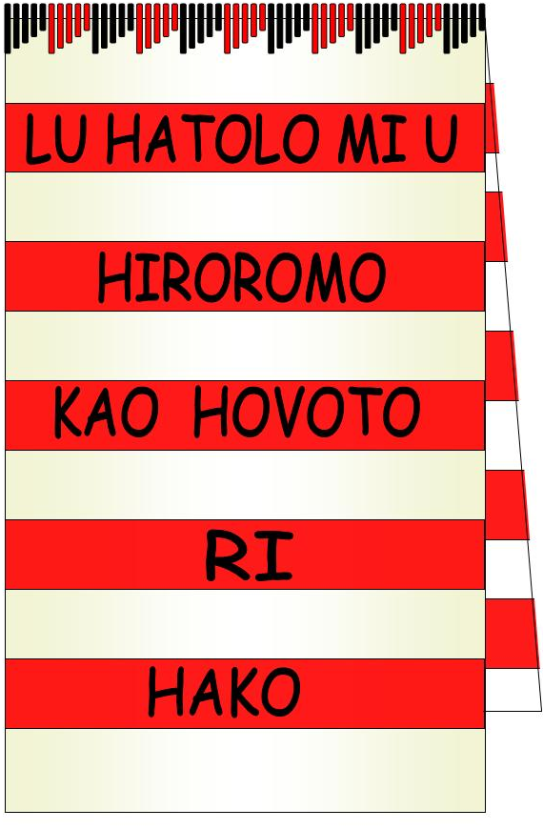
HWC TEAMS: QUARTERLY PROGRAM & REGISTER WIEA – Q1 & 2 2015

HWC Objective /  Strategy (SAP 2015-2017) | PROGRAM TEAM COORDINATORS | TEAM MEMBERSHIP
Development of Hako Resource Centre / Meri Seif Haus Q1 | Team A: Ruthy Sawa | Pauline Nawan, Crescenda Hoot, Mary Tenevi, Gela Rihene, Sophie Kisin, James Tsigoto, Serah Tsimogo, Helen Morris, Celesta Tohiana
Establishment of Hako  Resource Centre & operation of Meri Seif Haus Q2 | Team B: Ainsley Hansiana | Ruth Lenga, Rebecca Lynne, Rani Beatrice Lipson, Amalani Salu, Mary-Anne Sulis, Lydia Raton, Colleen Rossy, June Lagom, Jennitha Hansiana, Wendy Hakene

1. VISION (Mehe) Hako: Lu hatolo mi u hiromomo kao hovoto ri Hako Collective

English: In the spirit of love and true sisterhood, we the women of Hako Collective are called to build a safe, secure and just environment within our families and communities AND Create an integrated sustainable development that will establish a better future for our children and children’s children.
- MISSION (Tukui) Hako: Aga u Kao ri Hako ke hihitaguhu, hihatuts, bate hatapa haniga e naga a han I tagaga

English: In response to the current situation in our community, we the women of Hako are committed to work together, help each other and teach and train our people to build a safe, secure, just and peaceful society creating an environment conducive to sustainable, integrated development for the common good of our children and their children.
- OBJECTIVES
a) To facilitate and co-ordinate Trainings/Workshops and Forums for the women’s groups in the Hako Area and maintain the spirit of friendship, partnership with women and the community in peace building, reconciliation and weapons disposal in Hako; and

b) To educate and train women and youth, developing their human capacity in empowering them with life skills, leadership and decision making, community advocacy supported by partnership Women’s Federation, Government, CSO and Non Government Agencies to access the necessary educational resources; and
- To ensure and endorse representation of women in politics and in decision making bodies in government, non government organisations and the private sector; and
- To represent women and their families concerns and to advocate for their economic empowerment and development through projects that aim to reduce poverty in families in Hako; and
- To represent the women of Hako and network with, national, pacific and international women’s organisations and women’s movements’ and
- To protect Hako’s environment, heritage and culture and to promote the proper management of natural resources as mothers of the land in a matrilineal society with Environmental Education and Advocacy (EEA) and Pacific Black Box (PBB) teams; and
- To source funding and management capacity for women’s infrastructure and community development and programs in Hako to ensure effective delivery with accountability for sustainable development with Community Development (CDI) teams and PBB media; and
- To strengthen and encourage the marginalized persons or groups of persons in society by providing literacy, life enhancing skills, formal education opportunities and advocating for health services and family well being through Womens Integrated Education and Advocacy (WIEA) and PBB teams in Hako.

HWC EXECUTIVE assessment and endorsement of WIEA team program | Q1 ‘15 | Q2 ‘15 | Q3 ‘15 | Q4 ‘15
Item A: Program is conducted on line with HWC Objectives & Strategy? | Yes | Yes | N/A | N/A
Item B: Program is in Scope with the HWC Objectives and Strategies | Yes | Yes | N/A | N/A
Item C: Program is in Budget with HWC capabilities? | Yes | *
Item D: Any Risks or concerns with the program? | * | *

_{COMMENTS:}

WIEA Report prepared by: | Mary Tenevi, Ainsley Hansiana, Ruthy Sawa, Marilyn Havini & WIEA team
DATE Report submitted to Exec: | Thursday 12th March 2015
Date Report presented to HWC Membership: | Tuesday 10th March 2015

HWC TEAM: WIEAs |  | Women’s Integrated Education and Advocacy : |  |  | Program days are THURSDAYS weekly
Program  Day No. | DATE | HWC  Objective | Program | Activities | Who is  Responsible  (Team Leader) | Cost of Activity | Register date &  sign when completed
1 | 26/2/15 | b), h) | Introduction to WIEA & Planning for 2015 | Recruitment of new members, HWC overall plan for 2015 | M Havini with WIEA Team Leaders + 2 | Nil
2 | 5/3/15 | b), h) | WIEA Program for 1st and 2nd Quarters 2015 | Digital computer entry of WIEA Program | M Havini, M Tenevi,  R Sawa, R Lynne | Nil
3 | 12/3/15 | b), d), h) | Team Training with ‘Life Clock’ | Training Module from Handbook & Group activities | Mary Tenevi (Trainer) | Nil
4 | 19/3/15 | b), d) h) | Team Training in Child Protection | Training from PNG & AROB law ‘Lukautim Pikinini Act’ | Ainsley Hansiana, Anna Sapur | Nil
- | 26/3/15 | c) | ISSUE OF WRITS ABG Elections | HWC accompany Hako Women Candidates to nominate for ABG Elections at Electoral Office, Buka Town | HWC Membership & Women of Hako supporting Hona Holan & Patricia Kapapal | individual women  donations to fundraising for candidates
- | 2/4/15 |  | NIL | EASTER
5 | 9/4/15 | a), b), d), h | Preparation of Resource Centre & Meri Seif Haus | -Prepare & rehearse drama (skit) highlighting FASV & role of WIEA, Meri Seif Haus & FSS  -Write Invitation letters to Hako Women’s groups for bookings | Ainsley Hansiana & Gela Rihene (drama)& James Tsigoto (music) | Nil
6 | 16/4/15 | a), b), d), h | OPENING of HWC  Hako Resource Centre  & WIEA Fundraising Activity | -Presentation of the Drama & songs’ Health B’long Mama’ & ‘There’s a place for you’  -Announce WIEA resources available from RC to borrowing members  - WIEA fundraising activity: Catering arrangement | -Ainsley Hansiana & Gela Rihene (drama)& -James Tsigoto (music)  -M Havini & R Sawa (WIEA Resources & DVDs) | HWC Exec budget  & WIEA donations
7 | 23/4/15 | a), b), d), h | CUP TEA FUNDRAISING  & Preparation for WIEA Awareness on FASV, Child Protection & Resource Centre Services | Thursday bookings for Haku Women’s Fellowships, KWAs, CSOs to attend RC library & associated activities Play DVDs, run workshops e.g.  -Life Clock, | WIEA Team leaders & Teams | WIEA food donations,  Flex cards,  DVD copies of resources, & photocopies of materials
8 | 30/4/15 | a), b), d), h | Awareness Program  as above | -CEDAW & ABG legislation on ‘Gender Equity, Women’s Empowerment, Peace & Security’ | Anna Sapur, Ruthy Sawa, Cecelia Hera, Helen Morris | Transport,  Power,  Flex cards  Refreshment
9 | 7/5/15 | a), b), d), h | Awareness Program  as above | - Lukautim Pikinini Act, | Ruthy Sawa & Ainsley Hansiana | Transport,  Power,  Flex cards  Refreshment
10 | 14/5/15 | a), b), d), h | Awareness Program  as above | - Women’s participation in politics | Hona Holan, Patricia Kapapal, Dorcas Gano & Ruthy Sawa, | Transport,  Power,  Flex cards  Refreshment
11 | 21/5/15 | a), b), d), h | Awareness Program  as above | - Gender issues & elections | Hona Holan, Patricia Kapapal, M Havini | Transport,  Power,  Flex cards  Refreshment
12 | 28/5/15 | a), b), d), h | Awareness Program  as above | - Mental Health & Disability | M Havini, | Transport,  Power,  Flex cards  Refreshment
13 | 4/6/15 | a), b), d), h | Awareness Program  as above | - Bougainville Peace Agreement | M Havini, A Sapur | Transport,  Power,  Flex cards  Refreshment
- | 11/6/15 | a), b), c),  h) | HWC AGM / Elections / 9th Anniversary | C/- HWC Executive  Annual Report from WIEA Team Leaders | D Gano & Executive  R Sawa & Ainsley Hansiana | HWC funds
14 | 18/6/15 | b), d) h) | WIEA reorganization & planning with newly elected HWC Executives | Programming & planning logistics for ongoing WIEA projects | WIEA Team Leaders R Sawa & A Hansiana | Nil
15 | 25/6/15 |  | WIEA strategize for 2015-2017 SAP projects | Complete program template for Q3 and Q4 acc to SAP | WIEA Teams & Leaders | Nil

Quantity | Funded Item | Units | Description | Funding source | Receipt No | Unit Price | Total
6 | Bougainville Peace Agreement | Village Assemblies | BWF North Bougainville Program | SPSN |  | Hako COE - varied | K8, 000
x2 Team Leaders | Communications for Awareness bookings | Flex cards | Phone calls prep with clients | WIEA cup tea fundraising budget |  | 2xK10 flex | K20
6 - 12 | Power for Awareness Bookings | 6 wks x 1-2 teams | Diesel / petrol for power generation | Village Assemblies |  | K20 (4 litres) | K120
6 | Transport | PMV am/pm | Teams to VAs | WIEA cup tea fundraising budget |  | K100 pd ‘drop off’ costs | K600
6-12 | Refreshment Sessions | Village Community Groups | VA / WIEA Awareness Programs | Village Assemblies with WIEA |  | K100 | K600
 |  |  |  |  |  | WIEA Subtotal | K620
 |  |  |  |  |  | VAs@  K120 ea | K720
 |  |  |  |  |  | BWF project | K8, 000
 |  |  |  |  |  | TOTAL | K9, 340

