www.hakowomen.org
hakowomen@gmail.com
Donations

Newsletter - January 2020
Dear friends and supporters of Hako Women’s Collective,
Every year seems to be a big one for Hako Women’s Collective, and 2019 was certainly eventful. We’ll outline some highlights in this newsletter; for more see our website.

Independence Referendum
The biggest news of course has been the referendum on independence for Bougainville, in late November 2019. Beforehand, in preparation for the referendum, HWC conducted a program on Civic Education with 6 large scale activities throughout Haku, a Radio Awareness program and many village and church-based awareness sessions.
During voting, five teams from HWC provided the crucial role of volunteering as domestic observers of polling over the 6 days of voting in Haku. A further 20 HWC members volunteered as observers of vote-counting. Some of the HWC observers are pictured here with observers from the Pacific Islands Forum. Read more

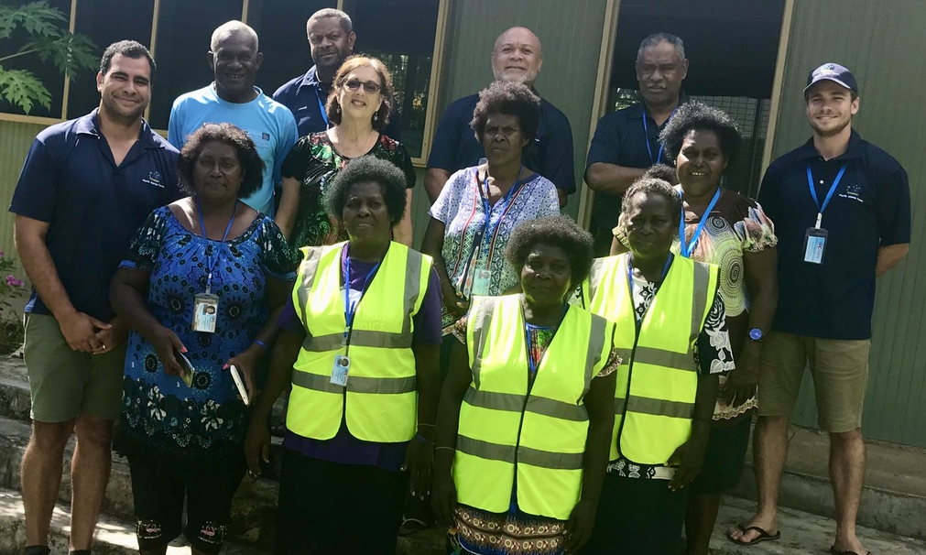
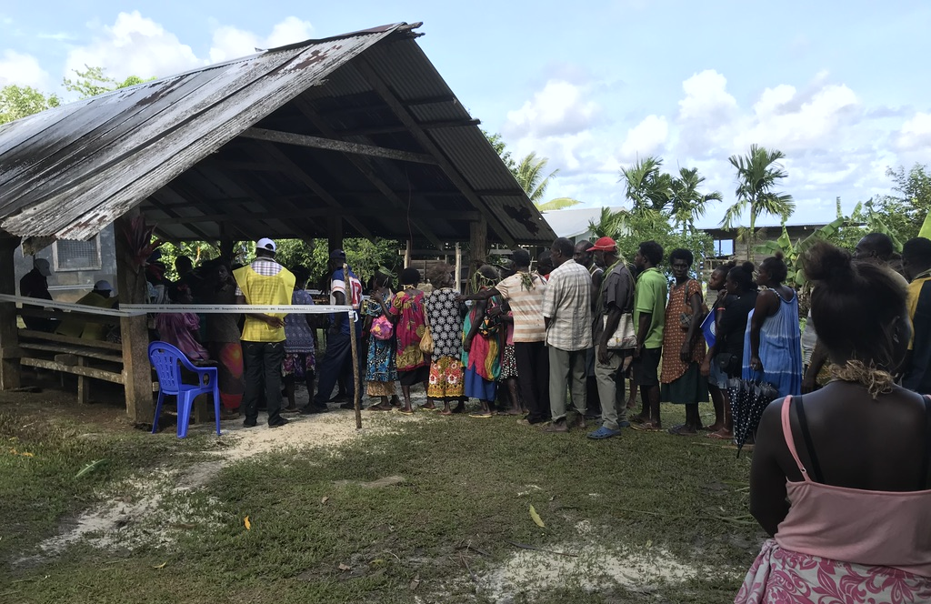

Agricultural Hub Project
HWC’s major project for this year was completing the third of HWC’s planned buildings, the Agricultural Hub, with funding from an Australian Aid Friendship Grant and with help from our friends Partners in International Collaborative Community Aid (PiCCA). The Agricultural Hub project, part of HWC’s plan to develop food security for Haku, includes:
- A rice mill providing a service for people to mill rice they have grown;
- “Backyard Gardens” program helping vulnerable people to support themselves;
- A demonstration garden at Luman Hipakoko; and
- The first Haku Agricultural Show on 8 September 2019, attended by over 600 people.
Read more
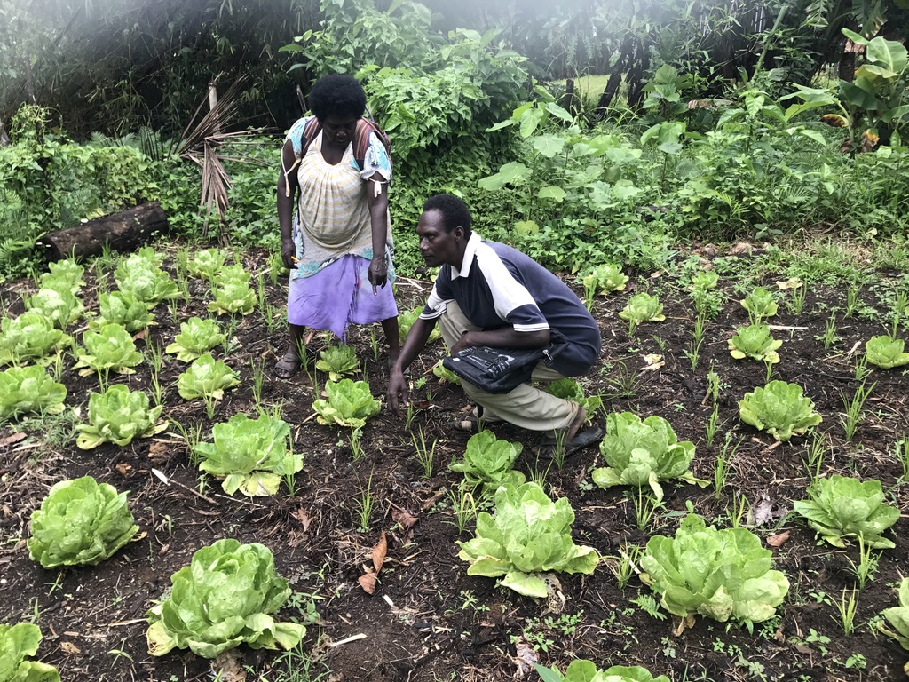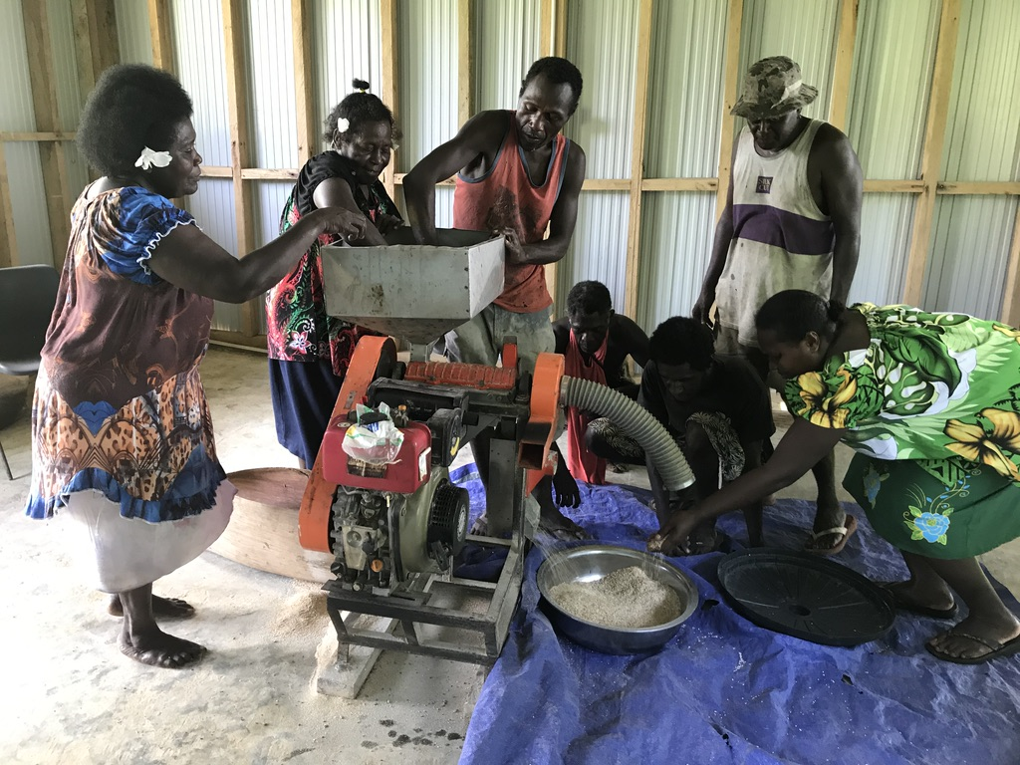

Ongoing activities
Through 2019 HWC has continued to run its key programs from its base at Luman Hipakoko.
EVAC (End Violence Against Children) Awareness Campaign, provided by HWC to all of Bougainville through funding from UNICEF via the PNG office. ​HWC ran 5 major programs, each with many activities, in 2018-2019. Read more

FASV (Family & Sexual violence): The Meri Seif Haus & Family Referral Centre is available 24 hours a day, 7 days a week, for women and children in crisis. In 2019 we averaged about 3-5 clients per week at the Centre – and many others are receiving ongoing counselling in their local areas of Haku where HWC has trained up 7 male and 12 female counsellors.
We also work with the Mental Health Counsellors newly trained and installed at the Lemanmanu Health Centre in central Haku. We have about 40 clients per month: some referred from HWC, others are police cases. HWC partners with all the Law and Justice and Health organisations, and our President is on the Bougainville FASV Committee.
The HWC Human Rights Program, in partnership with the Bougainville Women Human Rights Defenders Network (BWHRDN), is developing projects in each Community Government Ward. ​In 2019 our 12 mature Human Rights Defenders mentored young women and accompanied 10 young women to Nazareth Centre for training. Haku community is becoming receptive to all our programs and there is a remarkable improvement in peaceful villages.
Library: The library is now opened every day by HWC staff volunteers for reading and drop-in visitors. The Head Librarian, Marina Levi, keeps all in order when she attends as staff on Thursdays. Marina has just completed TAFE studies Certificate II in ‘Customer Engagement’ from South Australia TAFE via extension studies, thanks to a scholarship from the Port Moresby Women’s Business Association which paid her fees. With funding from INDIGO foundation, we are able to set up reading circles and have decided to launch these by holding a ‘Back to School’ essay writing competition with school stationery packs as prizes.

Thank you to our Supporters
We would like to thank all the people and organisations who have generously supported us.
During 2019 HWC entered an agreement with the indigo foundation, which is providing funds that enable HWC to pay a small allowance to members who provide services at Luman Hipakoko. HWC also receive funds to pay for a mower each month and for 20 litres of fuel each week to operate the generator for a few basic hours. This has made a tremendous difference to the women, some of whom have been giving large amounts of time over many years without pay. The allowance makes it possible for them to commit to working regular hours, to keep services operating at Luman Hipakoko.
We have received generous donations from C3 Church and members at Cherrybrook in Sydney. They have blessed us with cash funding that has kept the services afloat when everything else fails, breaks down, urgent needs emerge etc. Dear partners from PiCCA, who played a key role in getting the Agricultural Hub completed, and Helen Dakin who keeps the website going and the bank account ‘alive’, are all appreciated as dearest friends to HWC.

Future Plans and Needs
In addition to our ongoing work, we have more projects on the horizon.
- On New Year’s Day we welcomed back Stephanie and Steve from PiCCA for 10 days to help us design and document our operations with professional input.
- Our partnership with Disability and Haku’s Hatsipito Organisation is high on our list of areas needing urgent input and strengthening. Currently we have no funding at all for this work.
- HWC is considering a request from the Department of Distance Education, to become a Flexible Open Distance Education (FODE) centre for students who had no offer to continue school beyond Grades 8, 10 or 12 (due to lack of space and resources).
And finally to our needs. We make every kina go as far as possible, but there is always a need to find money for small and large expenses. If you are able to help with a single or regular donation, however small, it can really make a difference.

- 100 Kina ($47) per week could help us establish Disability Services at the Resource Centre.  - 30 Kina ($A13) pays one Counsellor on site for a day.  - 50 Kina ($22) pays for travel for one HWC member to provide training etc.  - 100 Kina ($47) pays for HWC to staff the Meri Seif Haus (Women’s refuge) for one x 24 hour period.  - 500 Kina ($220) pays for fuel and maintenance of water pump or generator. | Donations  To donate to Hako Women's Collective, ​please pay your donation into:  BSB: 082062  Account Number: 154948347  Account Name: Helen Dakin itf HWC  Email us at hakowomen@gmail.com for a receipt. Donations are not currently tax-deductible in Australia.

Thank you again for your interest and support. We hope that 2020 will be a year of blessings for you all.

Dorcas Gano
President, Hako Women’s Collective

