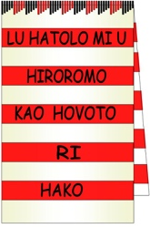
HWC BOUGAINVILLE REFERENDUM REPORT
Hako Women’s Collective
P.O Box 699, Buka, Autonomous Region of Bougainville
Contact President Dorcas Gano ph +675 72701250

14th DECEMBER 2019
CONTENTS
- HWC observer accreditation & BRC Requirements & Training
  - Preparation and Training
  - HWC Observer team
- HWC OBSERVATION
  - HWC Objectives as Accredited Observers
  - HWC Observation Program
  - HWC Polling records
  - HWC Polling Observations in HAKU
  - HWC Counting Observations at the BRC Counting Centre HUTJENA
- HWC EVALUATION & RECOMMENDATIONS
- HWC PRESS RELEASES
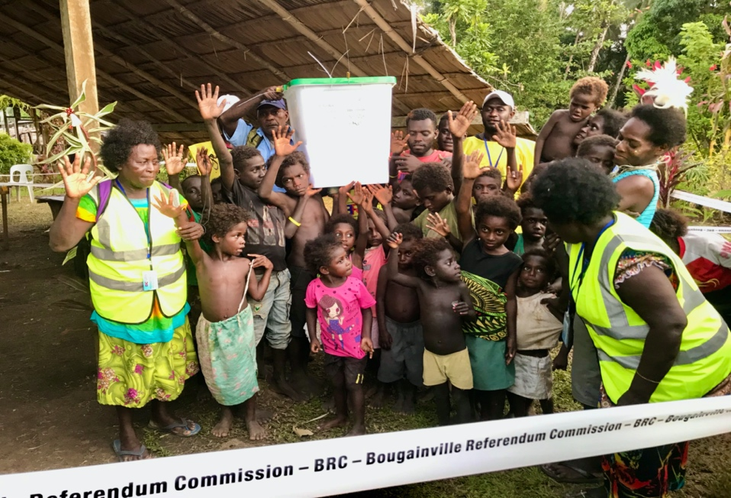
Photo: Conclusion of Hanpan polling – police escort include children with HWC Accredited Observers
- HWC observer accreditation & BRC Requirements & Training
1.1 Introduction and approach taken by the HWC observers; preparation and training.
HWC determined to apply for Domestic Observer Status to BRC in response to the advertisement calling for Bougainville Community Organisations for this role. Having already completed a CIVIC EDUCATION program throughout Haku, the HWC members felt responsible to follow through with this opportunity to be visible support to our people as they entered the Referendum period. HWC held a General Meeting to vote on the decision of applying for Observer Accreditation for the Referendum. The decision was unanimous and included non-members from FBOs who partners with HWC in the IRI funded Civic Education program. Of the Civic Education teams of the 30 presenters, 21 chose to become Accredited Observers. HWC had no funding for the Observer team and every volunteer well understood they would be doing the work without financial support. For this reason, we placed the teams in their local areas so they could access each polling station on foot. Marilyn Havini as HWC mentor chose to use her car and travel between teams to confer between the teams as support and to assist and liaise between the teams to ensure went well.
Our application was eagerly accepted by BRC who provided relevant background documents and formal application forms to our President. We were also given access to their website to familiarise ourselves with the duties and responsibilities before we proceeded: http://bougainville referendum org/ Email address : observers@bougainville-referendum.org
A Referendum Handbook for Observers, Scrutineers and Media (October 2019) was also made available.
Accreditation Process;
BRC 301 Application for Accreditation of a Referendum Observer Group
BRC 302 Nomination of Representatives of a Refererundum Observer Group
BRC 303 Nomination of Liaison Officer of a Referendum Group
BRC 304 Representatives to receive Badges and Vests through Liaison Officer.
Following the signing of a contract with BRC led by Amanda Masono and Noreen Korikai with HWC President Dorcas Gano and Secretary Eva Suitawa, the HWC Secretary, Eva, was appointed to be the official Liaison Officer for the list of 21 HWC members and supporters who volunteered for this role. Each of the observers was accredited with a photo ID and badge and were supplied high-vis yellow/green ‘Accredited Observer’ vests. These were worn at all times when on duty. Security checks were in place at every venue and HWC respected these provisions.
Training: HWC Observers attended meetings and briefings at BRC and IFES offices and all-training sessions before the polling (Monday 11th November at Adeeves) and again prior to the counting (Saturday 7th December at the Hutjena High School Hall). Marilyn Havini and Dorcas Gano also attended an official BRC Information Session for CSOs at the IFES Conference Room on Wednesday 13th November.
Evaluation of Preparation to be Accredited Observers
All of the BRC training meetings were well attended by the HWC team who agree they were well run, clear and informative. Information on the entire process was comprehensive, well presented and inclusive with PowerPoint presentations and photo demonstrations. The HWC team were well prepared for their roles; our duties were well understood, and we also had clear understanding of other roles including the polling officials and their titles, the scrutineers, International Observers, and BRC officials with oversight. We took clear note of our Do’s and Don’ts.
1.2 HWC OBSERVER TEAM
No. | NAME | POLLING TEAM | VENUES /DATES
1  2  3  4 | Anna Sapur  Bridgitte Tologina  Marina Levi  Aloysious Tsulan | 106  Elutupan / Hanpan | Munapul  Putu  Kungkungu  Honuto  Hanpan | Monday 25th Nov  Tuesday 26th Nov  Wednesday 27th Nov  Thursday 28th Nov  Friday 29th Nov
5.  6  7 | Dorcas Gano  Elizabeth Lambert  Judith Pena | 107  Tanreki /  Lemanmanu 1 | Marau  Pitono  Binau  Lihuna | Monday 25th Nov  Tuesday 26th Nov  Wednesday 27th Nov  Thursday 28th Nov
8  9  10  11 | Eva Suitawa  Jane Sesmo  Veronica Biata  Mark Soli | 108  Lemanmanu 2 | Pisibelo  Tanhil  Tanukalu  Tanhil | Monday 25th Nov  Tuesday 26th Nov  Wednesday 27th Nov  Thursday 28th Nov
12  13  14 | Clara Omi  Donica Hugese  James Pena | 109  Lumankoa | Tsistil  Binasoa  Mangoana  Tanhum | Monday 25th Nov  Tuesday 26th Nov  Wednesday 27th Nov  Thursday 28th Nov
15  16  17  18  19 | Marian Rihene  Gene Hakiolo  Jesmaine Gano  Terrence Pena  Melissa Sassin | 110  Lontis | Ptu  Rekreki  Tanakobo  Tegese  Malamalakoa  Tegese | Monday 25th Nov  Tuesday 26th Nov  Wednesday 27th Nov  Thursday 28th Nov  Friday 29th Nov  Saturday 30th Nov
20 | Marilyn Havini | 107  109  109  106 | Marau  Binasoa  Tanhum  Hanpan | Monday 25th Nov  Tuesday 26th Nov  Thursday 28th Nov  Friday 29th Nov
21 | NCO CAPS Paul Kolen | 106 | Hanpan | Friday 29th Nov

- HWC OBSERVATION
  - HWC objectives as Domestic Accredited Observers
- To ensure the Bougainville Referendum would be conducted according to International Best Practice and to prove whether the results will be fair and credible or not.
- To provide Observation services to the Haku Community with a view to provide an accurate report on the inclusiveness and credibility of the polling across the entire Haku Constituency.
- To provide gender balance to each Polling Venue with presence of women as a public encouragement to voters to turn up and participate irrespective of being male or female, old or young or disabled
- To observe whether the Civic Education work HWC had carried out from September to November had resulted in inclusive participation by youth, the disabled and first-time voters targeting 18-35-year old’s.
- To observe venue arrangements at polling stations, as to quality set-up & maintain a peaceful, conducive atmosphere, throughout the day at each polling venue.
- To show concern for the welfare of everyone including noticing that the needy were supplied with refreshments and comfort requirements - especially the voters with disability, those requiring postal voting visits and officials.

  - HWC Observation and Program of the Polling Week
HWC teams were dedicated and we had 100% attendance at each polling station on each day of polling in Haku. Transport support was provided to various members of the team by Marilyn Havini, Haku Ambulance, Edward Bukil, JASTA PMV, Pitono Star and PMV. Polling in Haku was scheduled from Monday 25th until Saturday 30th November. Our Observers were in position each day before Polling was opened and we remained at our posts until the Ballot Box was securely carried away by the Police under guard at the end of each day.
A report came to HWC Observers from the female Police CAPS that their accommodation had no water and they had to leave the guarding of the ballot boxes in their accommodation to walk down the cliff to wash in a waterhole out of sight and locality to their duty of guarding. They did set a guard to take turns on watching the boxes – but is should be noted that Haku offers many more suitable venues for the police to use in future elections.
HWC members provided back-up refreshment and toilet stops to International Observer teams at the HWC Resource Centre and Havini home in Ngalkobul Village. Our Domestic Observer Team compared notes with these International Observer teams throughout the week, and later at the Hutjena Hall Counting Centre.
International Observer visits to Haku:
Monday 25th November – 3 cars Australian team of 11 observers
Tuesday 26th November – 1 car New Zealand team of 2 observers,
& 1 car United Kingdom team of 2 observers
Thursday 28th November – 1 car European Union of 2 observers

Friday 29th November – 1 car Pacific Islands Forum with 1 observer

Our Domestic Observer teams sorted out their own viewing positions and moved unobtrusively around the venues to observe that all remained peaceful and followed best practice as we had been led to expect from the BRC briefings and trainings.
- We consulted our printed United Nations Human Rights Checklists and made notes appropriately beside the various categories to observe.
- We recorded all the Seal Numbers (metal and plastic) as announced each day by the polling officials
- We noted all evident security in place and the environment throughout each day and witnessed the arrival and departure of the Ballot boxes in the hands of the police / CAPS each day. There were three trips to town by Police carrying ballot boxes at the end of voting days. HWC sent a representative to accompany these ballot boxes to the Buka Police Station to witness their safe arrival and storage under guard awaiting the counting process. Eva Suitawa went on Thursday, James Pena and Aloysius Tsulan went on Friday, Jesmaine Gano and Marian Rihene went on Saturday.
- We observed the general public and their behaviour throughout each day - especially noting freedom of movement and arrival / departures of voters – watching to see if there was any coercion or intimidation. We had expected to see men coercing women from past experience of general elections– but all of us were most surprised to see no evidence of this happening for the Referendum.
- We noted the scrutineers and their discussions with the voting public and the officials. They were present every day, all day and all behaved professionally and provided strong, supportive and friendly presence to all voters. We noted that they assisted groups upon arrival to indicate the voting process and where to enter and leave in neutral and impartial manners.
- We noted the occasional frustrations of voters whose names were not found on the roll, and the actions taken to as to whether they were turned away or offered Provisional Voting. We later discovered that some who were turned away were underage and just trying their luck wanting to use the Yellow envelope! They remained keen observers throughout the day.
- Each Polling team sealed their boxes with plastic seals until the final day when the last metal seal closed the top flap. This process was followed at each Polling Station.

Our teams remained in contact with each other throughout the week. We compared notes and concerns. Some teams joined together to complete the week when their own areas were finished. Those observers who finished on Thursday attended the Hanpan and Lontis Friday polling venues.

On Monday 2nd December, the week after polling was closed in Haku, our HWC Observers met at the HWC Luman Hipakoko Training Hall to report back with all their observations and records to the HWC group. Our Liaison Officer Eva Suitawa compiled all their records and this report is based on these records. At this meeting, the HWC Accredited Observers arranged for 10 of the initial team of 21 to continue at Hutjena Hall Counting Centre.
Arrangements were made for the team of 10 HWC Observers to camp nearby at the United Church Conference Hall, within walking distance to and from the Counting Centre.

  - HWC Polling records from observation

Polling tallies of the number of voters were announced at the end of each day by the Presiding Officer at each Polling Station.
HWC took note of these progressive tallies and the list below was collated by the HWC at our evaluation meeting on the Monday following the close of Haku voting.

Polling Team  106 | Polling team  107 | Polling Team  108 | Polling Team  109 | Polling Team  110
Elutupan /  Hanpan | Tanreki /  Lemanmanu 1 | Lemanmanu 2 | Lemankoa | Lontis
1154 total voters | 1498 total voters | 623 total voters | 1693 total voters | 1554 total voters
5 PWD female  voters | 22 PWD female  voters | 8 PWD female  voters | 11PWD female  voters | 10 PWD female voters
7 PWD male  voters | 12 PWD male  voters | 7 PWD male  voters | 19 PWD male  voters | 17 PWD male  voters
= 12 disability | = 34 disability | = 15 disability | = 30 disability | = 27 disability
TOTAL voters as compiled by HWC Observers from daily announcements by Presiding Officers at the polling stations in Haku = 6, 522
SUB TOTAL of people with disability (PWD) observed voting in Haku = 114
HWC has no figures for breakdown statistics of Provisional Voting and Declaration Voting, there were crowds of groups at a time that we observed who needed to use the yellow or white envelopes, but we were not given a count.
HWC does not have a list of postal voting either as these were carried out away from polling centres and opened before the days that we began observing at each polling booth.

  - HWC Polling Observations in HAKU
Freedom of Opinion and Expression
Throughout Haku, the community turned up early at each Polling station well before the Presiding Officer was ready to open up for voting. They came in large numbers and at several venues there were joyful group celebrations. In several places there were traditional dances including Bamboo Bands in Lontis, Sinsing Kaur at Hanpan and Binasoa, Mona Paddling (canoe dance) and the Tsigul at Marau, Beating the Garamut, blowing of conch shells and various combinations of procession and parades.

The bulk of the population turned up at each polling station in large numbers to begin polling each day. After the dances and celebrations, there were speeches and singing of the Bougainville Anthem, followed by prayers and official opening announcements were made.

Some voters chose freely to line up for a long wait while others decided to go home and return when there were no waiting lines. Although there was a lot of expression over voting for Box 2, we did not observe any arguments or coercion. Many voters came in family groups and had informed their children of the significance of this historic occasion. Countless times, we witnessed a child allowed to hold the parents had to enter the polling booth and cast their vote. This attests to peaceful happy environment and the sense of security everyone felt to be present.
Many voters were illiterate and asked for assistance from the Polling Official. We could overhear their request for which box was to be marked. We observed these situations as closely as permitted to check that the official was following the voter instructions; but as observers we had to remain outside the taped areas.

The venues each provided staked out areas for entry and exit of a clearly taped area to be respected as the polling venue. Officers were assigned to each task with layout of entry and exits plus placement for tables provided for roll check, inked fingers, and issue of ballot papers. A clear walking space was then provided to the voting area with privacy boxes arranged for secrecy in voting. Then there was another walk area for casting the folded vote ballot paper into the ballot box.

It was mandatory that everyone could cast a vote in either Box 1 or Box 2 - either way- no one would know. The exceptions being where an assistant was provided for the illiterate or the disabled (e.g. some blind people who needed one person to accompany them to mark the box as directed by the voter.) Everything was peaceful and respectful in every venue. The community obviously took the whole exercise as a human right to be respected.

Police presence was friendly and non-interfering; quiet and respectful and they remained outside the polling areas until called upon at closing – to take possession of the ballot box and provide security in transportation and overnight guarding.
PPC (Provincial Police Commissioner) Paul Tokura and high-powered police team also visited Haku on Monday to ensure all security arrangements were in place and being adhered to for a peaceful environment.

BRC follow up to Polling Station needs was timely – given the distance of Haku from Hutjena. HWC noted that the yellow envelopes ran out on the first day at one venue (Marau) and by Tuesday morning at Lumankoa, Lontis and Elutupan. We noted that extra envelopes were delivered Tuesday afternoon to each of these venues.
BRC officials remained in close contact to each polling station every day and carried out security checks and observed and advised the polling officials whenever they needed advice.
We were told by these Polling Officials that they only received one day of training the week before polling began. They wished they had more training on the new procedures introduced for the first time.

Apart from a visit on Monday by BRC Commissioner Patrick Nisira and a media team, no further media attended any of the Haku Polling Stations – our HWC Observation Team feel the need to provide a press release because there is need for media coverage of our entire constituency and the extraordinary historical event that has taken place here.
HWC Media team Taloi Havini and Jesmaine Gano filmed and photographed media coverage of cultural celebrations and freedom of expression prior to voting at various venues.

Freedom of Assembly and Association
The Polling Officials were very patient and awaited the opening programs from each community to be fully expressed before they stepped forward and declared the Polling Open. In several places the voting slowed down about 3pm yet the polling Officials remained open to the maximum time of 6pm in every case. In some places a last minute turn up required them to stay longer than closing time; in every instance everyone was able to vote.
High School teachers were ferried after work by a chief driving them to vote and other noted groups came in various crowds to specific venues freely and peacefully at various times of the day.
It was noted that leaders sat as community observers beside throughout the day and assisted their community groups to access the venues. In some cases, they showed concern when families reported someone missing due to illness or various reasons for not attending. These cases were brought to the notice of Presiding Officer who arranged for Postal Voting to be extended through at the APO (Assistant Presiding Officer) accompanied by a scrutineer and an observer to visit the voter requiring assistance on foot or by car.

Freedom of Movement
Transport is very difficult in Haku and the road has been almost impassable until the week of voting. It was an extraordinary effort some International Observer Missions made to reach Haku through mud bogs and roadwork equipment. Within Haku itself, the voters were able to reach their respective polling Stations, mainly on foot. A few cars and PMVs provided some additional help for freedom of movement.
Haku had a total of 23 polling venues in its constituency – in contrast to previous elections with only 6 (one to each previous Village Assembly). This is a whole new record for Freedom of Movement and access to polling venues for our people.

International Observer teams were always made most welcome to Haku by the general community, the chiefs and /or the scrutineers who would welcome them as they parked their cars and escort them to the Presiding Officer. We witnessed the International Observers enter the polling area and observe / question the polling officials.

ANU Observers accompanied the BRC Officials to check all Polling Stations on Monday as well.

Hon Malatan (ABG Minister for Veteran Affairs) came on Friday to Haku. He gifted K500 to the HWC to contribute to our expenses in appreciation for the HWC Observer team in response to praise conveyed to him by the Scrutineer Veterans. Our Observer team also had freedom of movement and were respected by everyone during the entire Referendum exercise.
Some centres concluded the voting day with drum beating (to alert last minute voters to hurry up and cast their votes before closing). Freedom of movement was allowed to the crowds who witnessed the official handover to police, and they accompanied the ballot box to the waiting transport. Some areas provided further dancing and processional celebrations from the venue to the police vehicles.

Non-Discrimination
All members of the community – and full households turned up to vote. We noted many Papua New Guinea residents and ‘in-laws’ or tambu’ attended freely to vote. Everyone lined up in single file and entered to roped off voting area on their own – so there was no chance for discrimination to be hidden. The whole voting process was open to view from 3 or 4 sides (depending on occasional back wall in some venues). Large groups of youth came to each venue and were treated as respectfully as their seniors. In some cases, deference was made to chiefs to vote first. In other cases, they chose to go last and vote at the very end of the day. People voted when they chose. The exception was when yellow envelopes ran out on the second day throughout all 5 polling stations. The people needing these were asked to return later in the day. Some youth, whose names were not on the roll were turned away on the first day – at Lemankoa, but the Polling Officials later invited them back and offered the yellow Provisional Voting forms. Some youths were under-age and just wanted to try to vote!
As a result of HWC Civic Education, noticeable large numbers of youth – 1st time voters - had enrolled and turned up to vote. Polling Officials made particular comment of surprise on the number of youths.

Non-Intimidation
All comers were greeted equally and welcomed by the ‘door keeper’ at each polling station. It was notable that they greeted everyone - whether male or female, old, mature adults, or youth. Shyness and fear were evident in some first-time voters, but in every case witnessed, they eventually entered the polling area and voted. In one case at Lemankoa, three women eventual were required to assure a mentally disabled youth to overcome fear and they were allowed to assist him inside the voting area. Once he had completed his voting, he wanted to shake hands with bystanders out of sheer joy before running off in shame. Some people with disability were extremely unsure of how to approach and line up like everyone else. In every case we witnessed kindness and encouragement and invitation to go ahead in the lines. HWC observers found the whole civic experience very moving and uplifting.

A situation concerning safety and security of HAKU female CAPS came to our attention when a young woman CAPS Officer reported to HWC President that she felt unsafe in the accommodation arrangements for the CAPS guarding the Ballot boxes each night. The accommodation was at Tanhil in a house with no internal doors and there was only a cloth hanging as privacy screen for her and female officers to sleep and dress. They were sharing the house with other male police officers. Although there was no incident to report, we advocate that better privacy arrangements should be made in any future electoral duty ‘security camp’ situation to avoid any future intimidation. Inspections of venues should be ‘gender-sensitive’.

Gender Equality
There was NO discrimination over gender in any of the Polling days in Haku. HWC presence may have contributed to people being on their best behaviour – as our women looked very official in our Accredited Observer vests and our continual presence was noted by the community. Our CSO has conducted gender-based education on equality throughout Haku since May 2005 and we have witnessed a major improvement in gender equality from our inclusive programs and civic education work.

Inclusion
People with disability were especially catered for with this referendum. A special Roll of PWD has been created through the Referendum preparations, Bougainville wide. The ward Recorders of Haku had noted the elderly and sick who would require postal voting This provision started in Haku the week before polling began from Thursday 21st November. Several elderly people did vote in the preceding days as early voters in Haku. The Ward Recorder was supplied with the Pink Postal Vote envelopes from the BRC Office.

The President for BPWD Organisation, Mr Sione Atua came to Haku on both Monday 25th and Tuesday 26th along with the Vice President Ida Kenneth (Bougainville Red Cross) to observe voting of people with disability. They visited all the polling stations in progress.
HWC noted the exact numbers of those with physical disability, blind, deaf, elderly, people with mental disability. We also noted that Presiding Officers catered specially for pregnant and nursing mothers.
The necessity to continue inclusive provisions of postal voting, provisional and declaration voting remains for the following reasons:
- Literacy issues
- Cultural issues of access to polling stations where ‘tambu’ relationships restrict
- Naming issues
- Memory / lack of institutional records
- Location

NOTE: Our observations of HAKU POLLING are also summarised in the Press release attached to this report.
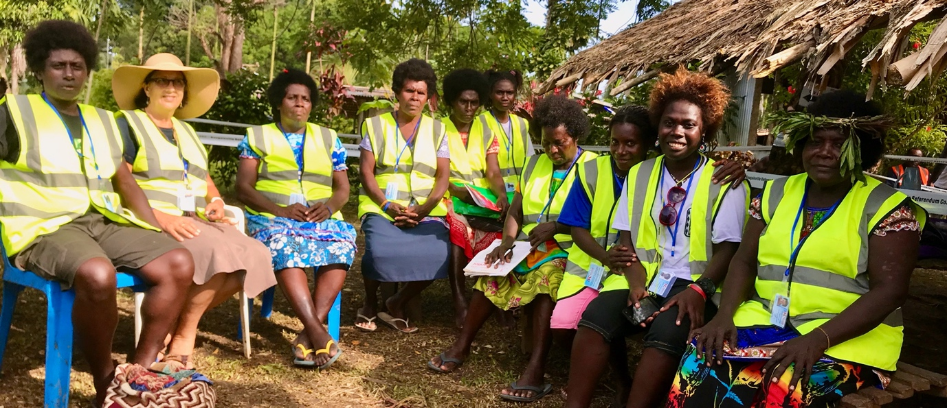
Photo: 10 of the 20 HWC Accredited Observers at conclusion of polling at Hanpan 29/11/19

  - HWC COUNTING OBSERVATIONS: BRC Counting Centre HUTJENA
HWC was summoned to attend as observers a BRC conducted Pre-Counting Briefing and Training session at the Hutjena Hall from 9am -11.30 Saturday 7th December. International Observers, Scrutineers and Media were all in attendance with the Domestic observers. After this informative briefing, we were accredited to attend in pairs on shifts over each 24hour period for the duration of the Verification and Counting of the Referendum.
The team set up a basecamp at the Hutjena United Church Conference Room within walking distance to the Counting Centre. We arranged for every shift to be observed by 2x HWC Observers Shifts began Saturday 7th December and concluded by 2pm Thursday 12th December a few days ahead of schedule.
Shift 1: 2pm-10pm / Shift 2: 10pm-6am / Shift 3: 6am-2pm
HWC COUNTING OBSERVERS ACCREDITED LIST
- Eva Suitawa
- Dorcas Gano
- Elizabeth Lambert
- Anna Sapur
- Clara Omi
- Bridgette Tologina
- Marina Levi
- Aloysius Tsulan
- Marilyn Havini
- Brenda Lambert
OBSERVATIONS
BRC set up notices listing the principles to be followed by everyone working in the Counting Centre and our HWC observations are made according to BRC criteria:
Security
On first approach to the venue, clear demarcation of all areas on site was apparent with taped fencing for accredited vehicles and people from all approaches to the centre. The area was open and under full security observation from all approaches. Clear signage directed people according to their right of access to various official areas. The whole centre was well laid out and the police checkpoints were in operation around the clock.
ID and labelled vests clearly identified Brown vests for all BRC staff and Counting Officials, Orange vests for Scrutineers, and Yellow/ green for Observers. The rules of engagement for each role were clearly iterated at briefing sessions and adhered to by everyone.
Security was established with police guards and security officials who signed-in all comers as the entered and exited during the week of counting. We had to present our ID badges on each occasion.
Neutral
HWC experienced polite well-mannered treatment from all officials and security during the entire process. We did not experience any discrimination over our role or our gender. We observed all other people involved were also well treated in polite and neutral fashion.
The counting process was conducted in a neutral respectful way – all ballot boxes were given consistent and proper handling according all we had been trained to observe. There were ballot boxes from three regions plus the international boxes. All received the same treatment:
75 North Region, 63 Central Region, 77 South Region, 33 Overseas (PNG/Australia/Solomon Islands plus 1 postal Box= TOTAL 249 BOXES
BRC established 8 stations with 2 tables assigned in each and a staff of 4 at each table was monitored by a Supervisor and ARO (Assistant Returning Officer). All of these staff were well trained with consistent application of methods in handling and opening ballot boxes and their contents irrespective of the area of Bougainville being processed. The origin of each ballot box was clearly marked in this first stage when boxes were carried under escort from the guarded shipping containers adjacent to the hall. The system allowed for every ballot box and the contents be handled in a neutral manner.
Accuracy
Clear guidelines had been established about how to treat each and every vote. We observed that these guidelines were followed consistently at every counting table and at the x24 verification computer stations. All Yellow, Pink and White envelopes were separated out to be sorted for checking against the Electoral Roll. This is where a lot of interest was taken by Scrutineers and Observers – standing by for hours on end to ensure every rejected or accepted vote was treated fairly.
The whole manual system was reasonably foolproof and easy to follow. The self-correction of mistakes we noticed occurred through tiredness or monotony by the counters. However, there were checks and double checks with sorting and counting that corrected these errors.
The staff were very accommodating to Scrutineer challenges and recounts and check with cross checks were constantly in progress. In every instance, every effort was made to be fair and eventual resolution had to satisfy the legal requirements of the election. Final counting saw INFORMAL VOTES as 1, 096 out of 1,818,067 total votes.
The validity of every vote was checked to have a signature from either the PO or APO. Some informal votes were the result of this signature being replaced by PO numbering the ballots instead of signing. Thus, an unfortunate error was the result of poor training of POs and or double checking of the POs understanding their roles out in the field. Our HWC observers were told on two occasions by POs that they felt the training was too brief (1 day only) before being sent out to run their polling station. In the interests of following the rules, the Counting Centre had to discard these votes even after being challenged by scrutineers.
Impartial / Anonymity
The final mixing of all ballot papers into a large open wire cage waist high at the front of the hall ensured the anonymity of the ballot papers once they had all been verified. These votes had been counted into 10’s and then groups of 100 to be dropped into the cage. There were also odd numbers of less than ten in last bundles.
Then two officers were responsible to randomly select 10 bundles into empty ballot boxes, forming bundles of 2, 000 to be counted back at the newly prearranged x16 Counting Stations. At this stage, after verifying exact numbers of ballot papers, the sorting process began. HWC observed the Counting Teams receiving extra training in this new procedure in the break period of setting up for this next step. There were three boxes to sort each ballot paper into: BOX 1, INFORMAL and BOX 2. Supervisors double checked every counter in operation at their respective stations and then the actual counting of piles was made and tallied. The votes were recorded by an officer at the end of each station and the bundles of ballot papers were taken to the computers managed by the logistic team on the stage and the ballot paper batch numbers were registered before being resealed into the guarded containers.
Transparent
All workstations were open to view and clearly visible from the floor with access walkways provided, and from above with access to the balcony to look down on all proceedings. We were able to observe all areas of the Counting Centre from 360-degree views and no activity by Counting Officials was hidden. The integrity of the secrecy of ballot papers was maintained until the final opening to sort and place within the correct boxes.
Professional
Overall working environment was pleasant with quiet respectful behaviour maintained by all parties throughout the process. The centre was well staked out and it is apparent that a lot of thought went into the design layout of floor plan and placement of teams and their furniture and equipment. This was re-designed in three stages: Verification, then the rearrangement of tables and stations and removal of computers for A-P (16 counting stations) with Mixing. Final rearrangement was made for a public area to announce the results.
BRC Chairman Hon Bertie Ahern along with President Momis (ABG), Hon Puka Temu (PNG), the BRC Commissioners, the BRC staff led by Mauricio and all the Scrutineers and whole teams of Observers were able to be present
The 24x Computer stations for the verification process with baskets for the accepted and rejected piles appeared to be well backed up with IT support. The 4 computer stations below the stage were busy with updating the rolls with verified names from earlier ABG Phase 1 and 2 Referendum Rolls – ready for future elections.
Efficiency of whole process was evident and proven by the early completion of the Voting and by the calm measured progress of the entire procedure. Timeline published the finish date to be up to 20th December. The results of a fair and credible Referendum were announced on Friday 13th December in Arawa and the return of writs to PNG Governor General was made. The whole Referendum process, according to HWC observation has been fair, credible and well done to professional world standards.
Inclusive
HWC observed both men and women BRC Officials. Some women were in senior roles including Amanda Masono (Manager for the Count Centre team) and Noreen Korikai who worked closely with us in her role with the External Relations Team. There were women in IT roles and at all levels of staffing. Men and women were professional in conduct towards each other and HWC were made to feel welcome and our Observation roles were appreciated. The ABG Scrutineer Team had Parliamentary staff of both male and female members present. Police presence included both male and female BPS and CAPS and Warders from Correctional Services.
There were 2 people with Disability on BRC staff at the Counting Centre. It would have been good to see more. The President for Bougainville People with Disability had Observer status and Red Cross provided a tent for the Disability Team beside the Counting Centre. So they could rest close by and continue to be present throughout the week.
Many of the Counting staff were young men and women and we observed them working very well beside their mature counterparts.
A few chairs were provided along walkways and cold water was appreciated by our observers from BRC who kindly assisted our HWC Observers to continue working for 8 hours at a time on solid shift work. We maintained our observation duties throughout the entire week from Monday 7th – Thursday12th December and our vigilant observation attendance was noted by BRC, IFES, Scrutineers and other officials present.

The results of counting: 97.7%majority voted for Independence.
BRC officially announced the results on 11th December 2019176, 928 voters cast votes out of the total names on the Referendum Electoral Roll. This figure represents an 85% voter turnout. This is the highest ever voting public in Bougainville.
Total Number of VOTES COUNTED 181, 067
Total BOX 1 Votes – GREATER AUTONOMY 3, 043
Total Box 2 Votes – INDEPENDENCE 172,789
Total Informal Votes: 1, 096

- HWC EVALUATION & RECOMMENDATIONS
HWC followed Evaluation M&E procedures including compilation of Observer notes from the team, team meetings and round table discussions of observations and records.
We also participated in consultation meetings with Bougainville Women’s Federation Observer team – especially ‘Stakeholder Roundtable Meeting No 3/2019 – Election Related Gender-Based violence on Monday 16th December at Adeeves with Federation, Save the Children, Dept of Community Development, Police, UNDP, NZ HC, BRC and separate meetings with International Observer Mission teams. We had an in-depth interview with the Pacific Islands Forum delegation of 5 officers on Thursday 12th December. At this meeting the New Caledonia Civil Registry process was discussed as a possible way forward for Bougainville to examine in establishing Voter ID for future Electoral rolls and increase accuracy of spelling of names.
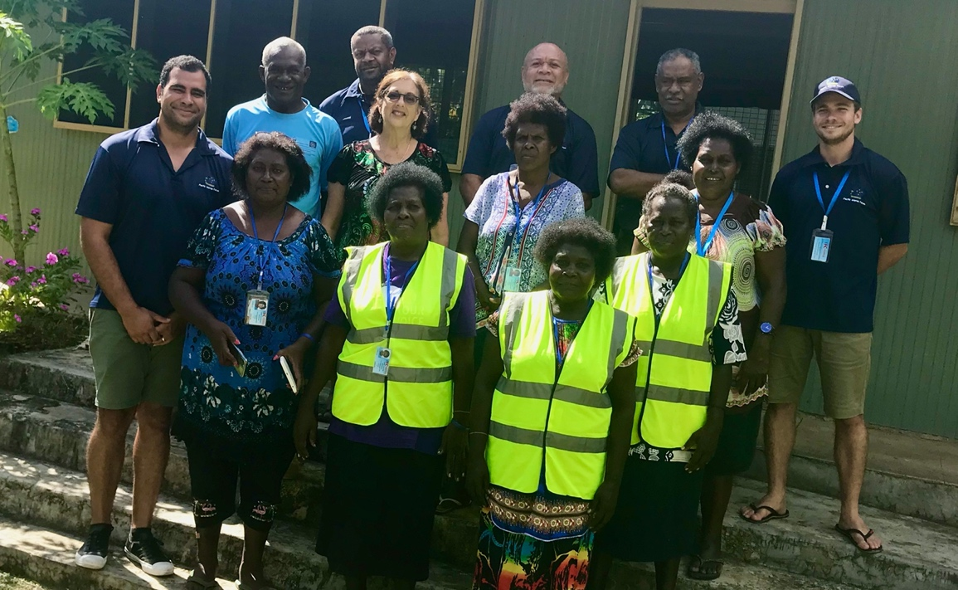
Photo: Pacific Islands Forum with 8 of the HWC Accredited Observers after roundtable consultation 12/12/19

HWC Performance: Liaison Officer Eva Suitawa commends all the HWC OBSERVERS who took part in both the Polling and the Counting Observation roles. Our teams worked cooperatively and supportively at all times. Having worked together in voluntary capacity over several years, we knew and anticipated each other’s needs. We shared our food and resources and cooked for each other and especially appreciated the hot tea after long sessions of shift work. We worked in pairs and exchanged shifts times to provide for rest and recovery as needed. When on duty, our observer team took their roles very seriously. Our evaluations have been carried out in a just, transparent and unbiased manner with professional dedication.
All the evaluations contained in this report have been considered before HWC met to determine the following recommendations.

Recommendation 1 – REFERENDUM to be accepted as genuine, Fair and Credible
This referendum has produced a positive result with a majority vote that is a clear mandate for Bougainville to request Papua New Guinea to grant Independence to Bougainville.
The percentage of the vote from the greater majority of the population is not just ‘wishful thinking’. HWC observed clear focused determination of the people with resolve and good will to become an independent nation. This was clearly proven at the ballot box.

Recommendation 2 – There should be no delay in preparing for the 2020 ABG Elections
HWC observed significant improvement in the overall electoral process in the conduct of the Referendum. This expertise must be retained for the upcoming ABG elections, and the sooner the better to capitalize on the systems in place and the trained personnel to carry over with OBEC, IFES and whoever can be retained from BRC.
The population of Bougainville is facing a ‘vacuum’ period unless definite steps are in place post referendum to assure everyone that the referendum had meaning and purpose. HWC recognises the potential for frustration and cynicism to cause discouragement and negative impacts if any delay to the correct legal processes are changed. Let the elections proceed on schedule and let the incoming ABG negotiate with PNG – after all – they will be the ones held responsible to deliver on the future government of Bougainville – irrespective of the negotiations.
The women of Haku and North Bougainville believe that a drawn out campaign period will only encourage a return to vote buying opportunists to stand for election and distract everyone from all the good work achieved by awareness on voting for right principled people who have the experience and expertise in good governance. There should be no fear among current politicians and leaders about going to the polls quickly – as everyone in Bougainville recognises quality leaders who shine through. We don’t need a circus of campaign tactics to vote responsibly.

Recommendation 3 – Retain Alcohol Ban for periods of future elections
HWC was most encouraged by the successful implementation of the temporary liquor ban during the Referendum period. Throughout Bougainville there was genuine respect for the seriousness of the election process and there was a marked decrease in Family and Sexual Violence incidents. We are pleased to report that our Meri Seif Haus in Haku had no clients during the period of the Referendum. HWC attributes this phenomenon to the absence of liquor related violence.
HWC recommends continued civic education and awareness be carried out throughout Bougainville to encourage responsible drinking behaviours and positive social drinking manners in all public and private locations including for drivers and passenger’s road and sea transportation.
HWC recommends that all future election periods of polling and counting should include a liquor ban throughout Bougainville.

Recommendation 4 – Polling Stations in future elections to be available in all 12 Wards of Haku for a 2-day period and to include the POSTAL, PROVISIONAL and DECLARATION voting provisions
Previous elections have provided 6 polling stations in Haku: (Elutupan/Hanpan/Tanreki/Lemanmanu/Lemankoa/Lontis) …whereas the Referendum provided 5 Polling Teams across 4-6 days in each area = 23 occasions across this Constituency. Future funding may not allow for this coverage, but we recommend a minimum of ONE polling station per each WARD = 12 Polling Stations.
The innovation for inclusion of YELLOW voting envelopes, PINK voting envelopes and WHITE voting envelopes proved VITAL to the success of the Referendum being INCLUSIVE. We observed large numbers of voters needing these provisions. It is most gratifying to see during the counting process that more than 80% of these votes have been legally admitted back at the Counting Centre during the Verification process.
These new voting options proved invaluable for the referendum and allowed for a full democratic process to occur. Therefore, the need remains to supplement each polling station with:
- Postal voting- (PINK ENVELOPES) for ill, weak, elderly, people with disability
- Provisional voting (YELLOW ENVELOPES) for those whose names were missing and may be on other rolls (e.g. previous rolls or in other locations).
- Declaration voting (WHITE ENVELOPES) for those who are aware they are on more than one roll and are declaring which roll and name under which they are electing to vote.
- The colour options need to be retained so there will be no future confusion.

Recommendation 5 – Updating the Bougainville Electoral Roll and Civil Registry
HWC recommends that the upcoming ABG ELECTIONS must continue to improve the system by consolidating the Electoral ROLL to accommodate all the corrections provided by the Provisional Voting procedures; we note that the inclusions of provisional votes were added as the counting proceeded but HWC asks BRC to inform all ward recorders to follow up with provisional voters as to whether their names are now on or off the new roll so that inclusions can be completed.
HWC observed the new provisions of PROVISIONAL TOTING, POSTAL VOTING and DECLARATION VOTING to be a democratic necessity for the following reasons:
- Literacy issues of name spelling variations / recording errors
- Cultural reasons for name changes used across time and memory lapses on previous registration records due to lack of written home filing records
- Education CV ‘official’ names and variations of adult name changes due to lineage / marriage / marital changes (all these situations are in flux and affect official records)
- Lack of official CIVIL REGISTRY for all citizens from birth.
- Location changes of residence across Bougainville / Papua New Guinea and location of registration records according to Ward / District / Province etc.
- Disabled and infirm voters who could not physically walk to the polling booth were visted by voting officials and were therefore included through the POSTAL voting provision.

Recommendation 6 – Polling teams and officials to receive more practical training prior to elections
Some Polling officials confided to our HWC observers that they were unsure of some of the procedures as they had only received one day of training and that was on the week immediately prior to deployment for the polling. Our HWC observers then understood why they seemed unsure of what to do with regard to the following areas of operations:
Observations at the POLLING sites revealed some inconsistency between polling teams in the following areas:
- Turning of people away if their names were not on the roll rather than offer Provisional Voting – this happened at two venues in Haku on the first day but were corrected on the second day. It is possible that some voters may have genuinely missed their right to vote. Australian International Observer mission noted this at Lemankoa along with our HWC Domestic Observers and it also happened at Elutupan on Day 1.
- A minor point of difference was noted with appropriate times to use of metal with / without the plastic seals.
Observations at the COUNTING centre revealed some inconsistency between polling teams and training preparation in the following areas:
- One whole batch of votes had no Presiding Officer signature on the back of the ballot paper– the back of each ballot paper had numbers recorded instead! All these good votes were cast aside as ‘informal’. We think these came from one of the overseas ballot boxes– in which case there was a very expensive failed exercise!
- Another area revealing potential lack of training was picked up at the counting centre when we witnessed other ballot papers totally empty of any official mark on the back. (Of course, these may well have been rightfully excluded as ‘informal’ if they had been illegally placed in the ballot boxes).

Recommendation 7 – Inclusion in ALL elections of DOMESTIC OBSERVERS and WOMEN OFFICIALS plus further Voter education and awareness on Civic Education programs must continue with practical training on how to vote correctly prior to elections
HWC remain committed to participate in all the above areas of future elections after noting the following
- HWC month of Civic Education awareness prior to the Referendum result of increased numbers of eligible Haku Youth and people with disability onto the electoral roll was noted.
- HWC messages on how to use the ballot paper correctly resulted in a very low count of informal votes for the Haku boxes (as observed at the counting centre).
- The presence of HWC teams in Official Jackets provided a welcoming and secure presence to the general Haku community who know our women leaders well and felt safe to approach the fenced off area.
- There were many people with disability who were first time voters, and many of them expressed appreciation for our presence and were reassured that they would be cared for in access and need to sit or be assisted physically.
- The voting communities had cleared and decorated their areas with care and they assisted the polling teams to set up and provide furnishings, shelter and refreshments. The local communities felt validated for their civic efforts in receiving both Domestic and International observers to record their efforts.
- We provided encouragement in gender balance to each polling site as there was only ONE woman to each polling team of 6 plus all the scrutineers were male veterans. Even the Scrutineers commented on their appreciation for our women’s presence to encourage women voters to enter the voting areas.
- As independent observers we – the HWC teams – were free to question and report the truth on all aspects of polling, verification and counting.
- As Accredited Domestic Observers we had the numbers to form five teams that could be on site all day in attendance and observing from ‘start to finish every day at every site from ‘before voting’ to ‘close of counting’.
However, HWC does need funding and transport assistance to meet the expenses of mounting such an operation for Domestic Observer missions. We note the generous appreciation donation of K500 from Hon Malatan ABG Minister for Veteran Affairs. This provided K20 to each of the 20 HWC observers to assist with transport costs.

- HWC PRESS RELEASE
HWC OBSERVATION of REFERENDUM– VOTING WAS FREE, FAIR and INCLUSIVE
True to our HWC Vision statement “the Hako Women’s Collective is called to build a safe, secure and just environment within our families and communities and create a safe, secure, just and sustainable future for our children and our children’s’ children” … HWC registered as domestic ACCREDITED OBSERVERS for the BOUGAINVILLE REFERENDUM.
Our Hako Women’s Collective (HWC) had already spent over 6 weeks (September – November) conducting a CIVIC EDUCATION awareness program throughout Haku and on Radio Bougainville and New Dawn FM. Our message of the value of maintaining PEACE accompanied informed explanations of ‘Autonomy’ and ‘Independence’ so the votes cast would be informed and credible. We appealed to first time voters, especially youth, women, the infirm and people with disability to make the effort for full inclusion- as this Referendum is a ‘ONE OFF ‘event.
From first day of HAKU polling on Monday 25TH until Saturday 30th November when the last polling booth closed in Haku, HWC had 20 Accredited Domestic OBSERVERS assigned in groups across every one of the 5 polling stations each day in Haku…from start to close of voting.
Our presence in luminous yellow/green vests and ID cards provided a welcome sight to all residents of Haku who openly expressed appreciation for our vigilant observation of voting proceedings. Recognition of women’s involvement balanced gender equity to each venue and encouraged happy peaceful conduct. HWC aim is to report, as volunteers, impartially on the conduct of this longed-for human right of our Bougainville people. We had prepared for this marathon task with excellent briefings from BRC, our own training and United Nations provided a Referendum Human Rights Checklist with observation criteria covering:
Freedom of Opinion and Expression, Freedom of Assembly and Association, Freedom of Movement, Non-Discrimination, Non-Intimidation, Gender Equality and Inclusion.
HWC OBSERVATIONS ON VOTING PROCESS: We congratulate the Bougainville Referendum Commission all the Polling Teams, the Police, CAPS and Veteran Scrutineers for a well-run Referendum in Haku.
We congratulate our Haku Community for a most joyous and celebratory week of cultural and political unity. There is no doubt that Bougainvilleans love their homeland and the opening and closing ceremonies included many traditional dances with conch shell and garamut calls plus flag raisings, Bougainville Anthem, pledges and speeches. Every one of these cultural events remained respectful and well-disciplined in approaching the Polling Stations. Observers, chiefs and general community remained on the outskirts all day at each centre but there was no evidence of intimidation or undue pressure placed on individuals. At each centre the venue became quiet once the Presiding Officer greeted all comers and announced Polling was open.
- The innovation for inclusion of YELLOW voting envelopes (provisional voting for names missing on the roll), PINK voting envelopes (postal voting for the infirm who needed visits from polling officials) and WHITE voting envelopes (declaration for voters registered in more than one location) proved VITAL to the success of the Referendum being INCLUSIVE. We observed large numbers of voters needing these provisions. It is most gratifying to see during the counting process that more than 80% of these votes have been legally admitted back at the Counting Centre during the Verification process.
- Presiding Officers at each polling station called for the elderly, the infirm, nursing mothers, pregnant mothers, the blind and lame and disabled to come forward and be assisted first to cast their votes. HWC noted the inclusion of people with disability at each polling station. We recorded the postal vote visitations made at each centre.
- HWC Observers noted a large number of excited youth and first-time voters plus male and female numbers of voters – in many instances the women outnumbered the men. Scrutineers knew their local communities and clearly indicated where certain households might require assistance to access the polling venues. As observers, we are confident that voting turnout in Haku was close to 100%.
- We noted the cases who were turned away –mostly youth whose registration was unclear - and if they were offered provisional voting on that day or subsequent days at other venues; these were relatively few overall. Polling for Haku: Elutupan/Hanpan 1154 over 5 days, Tanreki 1498, over 4 days, Lemanmanu 623 over 4 days, Lemankoa 1693 over 4 days, Lontis 1554 over 6 days.
- Police presence with CAPS for Haku was constant and non-intrusive, well supervised, friendly and professional. Security was maintained at all times.
- BRC Officials made visits to check all procedures in place at venues and the aspects of privacy, and quality control. They engaged with observers to see that we were satisfied with our observations.
- International Observer teams visited Haku over various days including Australia, New Zealand, United Kingdom, European Union and Pacific Islands Forum. All were well received and took genuine interest in processes and progress at each site visited. They also pulled up some scrutineers for not wearing their vests. We heard that BRC was in short supply for these.
HWC OBSERVERS ENDORSE THE REFERENDUM VOTING AS BEING CREDIBLE, FREE AND FAIR. THIS VOTING EXPERIENCE IS THE BEST STANDARD BOUGAINVILLE HAS EVER EXPERIENCED.
- HWC recommends that the upcoming ABG ELECTIONS must continue to improve the system by consolidating the Electoral ROLL to accommodate all the corrections provided by the Provisional Voting procedures,
- ABG should retain the services of the BRC trained staff and the excellent polling officials who have experience from the Referendum to conduct a credible ABG election in 2020.
- ABG should not delay the 2020 Elections: we need the next election to come quickly before the community is distracted by vote buying opportunists who might undo all the civic education improvements on voting according to principles and not bribes.
- The ABG Elections will require ongoing international interest and support to follow through on the Referendum setting in motion future negotiations.
- HWC appeals to OBEC and the ABG government to do all it can to ensure the next election maintains the quality and credibility standards of this current Referendum.
FOR MORE INFORMATION PLEASE CONTACT HWC PRESIDENT OR SECRETARY EVA SUITAWA +675 70584819 OR EMAIL taleo.sparky@gmail.com

