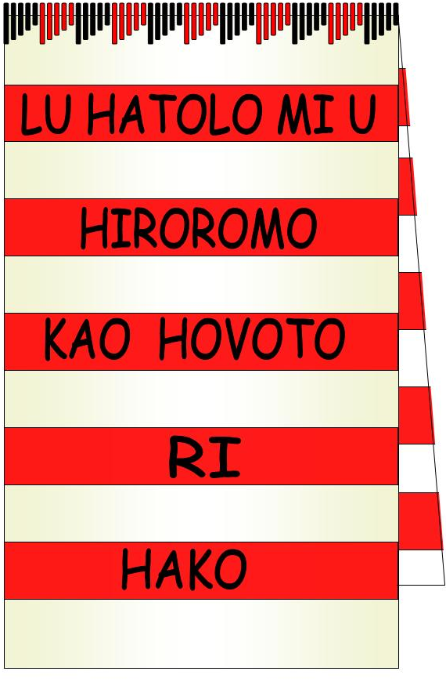
Hako Women’s Collective
P.O Box 699, Buka, Autonomous Region of Bougainville
Contact President Dorcas Gano ph +675 71110760

Women of Hako Developing and establishing with love for Hako

Policy: Countering Terrorism
Policy number | 3
Approved by HWC Executive | 17th December 2017
Commenced | 17th December 2017
Last amended | 15th December 2016
Planned revision date | 31st March 2017
Associated instruments/ policies | - Corporations Act 2001 (Commonwealth)  - HWC Constitution  - UNHCR 1325  - The Paris Declaration on Aid Effectiveness  - The Istanbul Statement on CSO Development Effectiveness  - The Australian Council for International Development’s Code of Conduct  - PiCCA Policies as a collaborative partner to HWC

- Overview
Hako Women’s Collective members and community partners including all office bearers, project teams and program trainers will use its best endeavours to ensure that its funding and support does not aid or support terrorism or proscribed terrorist organisations.
- Application
This policy applies to all Members.
- Policy
  - HWC recognises that national and international counter-terrorism strategy includes eliminating the financing by individuals or entities of any violent extremism or use of chemical, biological, radiological and nuclear terrorism. HWC also recognises that part of the PNG and ABG Government’s role in counter-terrorism is to
“support and develop international initiatives that build resilience against extremist groups that advocate terrorist activity…that build social cohesion, including interfaith outreach activities…[and that] coordinate capacity building…”
  - Within its capacity and through its work, HWC:
  - Checks lists of proscribed organisations on the Papua New Guinea and Australian Foreign Affairs and National Security websites before providing direct funding, support or resources, ensuring that the beneficiary is not included on either list
  - Ensures that organisations to whom funding, support or resources are being provided, know of, understand and comply with the legal and contractual requirements
  - Checks that HWC funding is received and used by the intended beneficiaries for development and/or relief
  - Informs the Papua New Guinea Police and, where Australian friends are involved, the Australian Federal Police immediately any credible information becomes available suggesting any links between HWC supported groups and proscribed organisations and/or terrorist activity.

Department of Foreign Affairs and Trade website, accessed 2 December 2014: http://www.dfat.gov.au/issues/terrorism.html

